EXPERIMENT 2

Create a Web Page for a News Website with Embedded YouTube Video, Hyperlinks, and Navigation Structure, and Insert Multimedia in a Webpage

Objectives
- 1. To design a simple news website homepage using HTML and CSS.
- 2. To learn how to embed YouTube videos into a webpage.
- 3. To implement hyperlinks and navigation menus for easy browsing.
- 4. To insert multimedia (images, videos, audio) in a webpage.

Tools Required
- Computer / Laptop with any OS
- Text Editor (VS Code, Sublime Text, Notepad++)
- Web Browser (Chrome, Edge, Firefox)
- Internet connection (for YouTube embedding)

Theory
- Hyperlinks ( tag): Hyperlinks allow navigation between pages or websites. Example: Visit BBC News
- Navigation Structure: A <nav> element groups navigation links for better structure.
- Embedding YouTube Video: YouTube provides an <iframe> code for embedding videos into a webpage. <iframe src="https://www.youtube.com/embed/VIDEO_ID">

Multimedia in Webpages:
  - Image (<img>): Display news images.
  - Audio (<audio>): Add podcasts or news audio clips.
  - Video (<video>):Insert local or hosted video files.

CODE IMPLEMENTATION

!DOCTYPE html>

<html lang="en">

<head>

<meta charset="UTF-8">

<meta name="viewport" content="width=device-width, initial-scale=1.0">

<title>EXPERIMENT 2</title>

</head>

<body>

<H1 align="center"><b>Global Daily News</b></H1>

<p align="center">Your Trusted Source for Latest Updates</p>

<hr>

<nav align="center">

<a href="#">World</a> |

<a href="#">Sports</a> |

<a href="#">Entertainment</a> |

<a href="#">Podcast</a> |

<a href="#">Contact</a>

</nav>

<hr>

<p>World News</p>

<p>Today's top headline: Global leaders meet to discuss climate change initiatives.

</p>

<img src="Screenshot 2025-10-04 222152.png" alt="Climate Change Meeting" width="600" height="350">

<p>

<a href="#">Read more on BBC</a>

</p>

<hr>

<h1>Sports Update</h1>

<p>Highlights of yesterday's football match with thrilling last-minute goals!</p>

<iframe width="560" height="315" src="https://www.youtube.com/embed/aqz-KE-bpKQ?si=zsuH5R8W9qm1RME8" title="YouTube video player" frameborder="0" allow="accelerometer; autoplay; clipboard-write; encrypted-media; gyroscope; picture-in-picture; web-share" referrerpolicy="strict-origin-when-cross-origin" allowfullscreen></iframe>

<hr>

<h1>Entertainment Buzz</h1>

<p>New movie trailer released today. Fans are excited!</p>

<video src="trailer.mp4" controls width="600" height="350"></video>

<hr>

<h1>News Podcast</h1>

<p>Listen to today's top headlines:</p>

<audio src="news-podcast.mp3" controls>

</audio>

<hr>

<h2>Contact Us</h2>

<p>Email: info@globalnews.com</p>

<p>&copy; 2025 Global Daily News</p>

</body>
OUTPUT
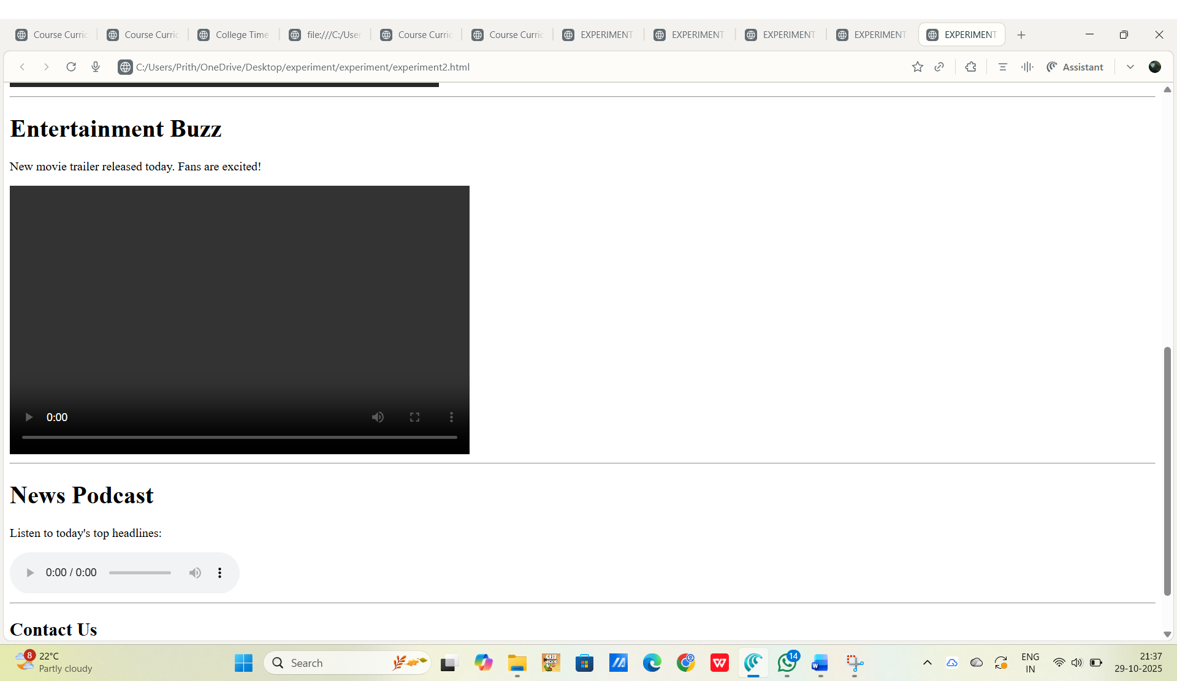
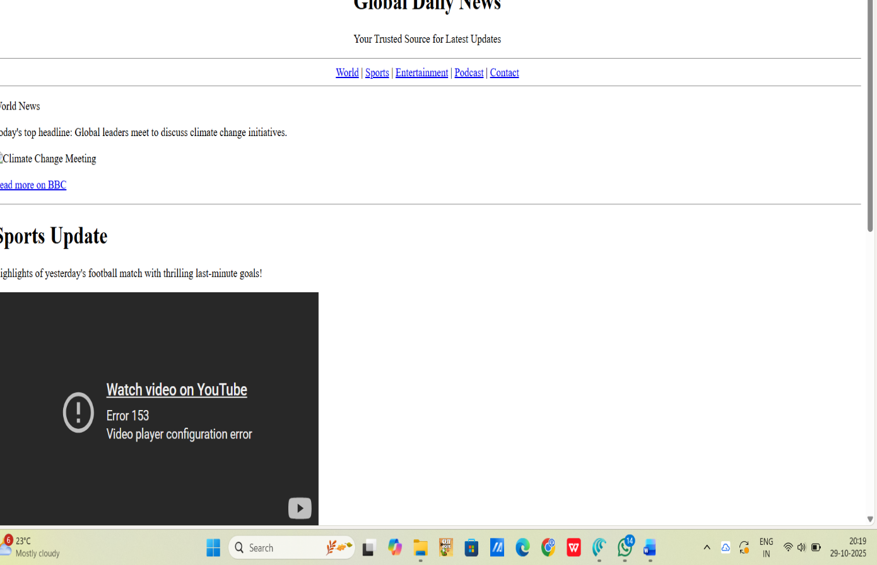

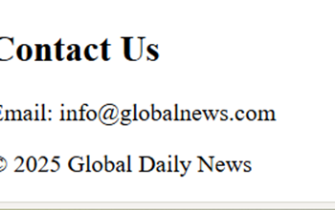

Outcome
- Successfully designed a basic news website layout.
- Implemented hyperlinks, navigation, multimedia (image, audio, video), and embedded YouTube video.
- Learned practical webpage structuring techniques for media-rich sites.

